System and Method for Variable Sparing in Large RAID Groups based on Disk Failure Probability Analysis

Contents

1. Invention Title 3

2. Abstract and Problem 3

3. Former Approach 3

4. Proposed Approach 4

5. Complete Solution and Novelty 5

5.1 Venn-ABERS Prediction for ‘Fail-*ing*’ Disks 5

5.1.1 Dataset source for result verification 6

5.1.2 Online VennABER Prediction Framework with SVM classifier 7

5.2 Variable Sparing Mechanism 8

5.2.1 Architectural overview 9

5.2.2 Workflow 10

6. Novelty 12

7. Utility: Industrial Applicability 13

# 1. Title

System and Method for Variable Sparing in Large RAID Groups Based on Disk Failure Probability Analysis

System and Method for Dynamic Hot Sparing based on Ranking of Failed Disk Drives in

# 2. Abstract

Disk Drive failure tolerance and optimum utilization of disks for storage are two of the most important challenges in enterprise storage industry. However, addressing both the problems simultaneously can be tricky. For example, to make the system fault tolerant, more storage needs to be added; this results in redundancy of storage. Moreover, since the spare disks are not user-addressable, the disk space goes waste until a failure occurs. Therefore, we propose a novel drive sparing mechanism which can significantly improve data availability by maintaining the optimal number of spare drives in the storage system. The method first identifies the critical disks that may fail in the RAID group based on Venn-ABER framework, and then implements a variable sparing mechanism where a few disks act as dual-purpose disks. We demonstrate variable sparing using two cases, first when maintaining a minimum number of spares is sufficient, and second, when maintaining a minimum number of spares is not sufficient. We also show that the introduced dual role of the disks reduces storage wastage by converting the spare disk to data disk if the spare is not needed and vice versa. In this paper, we explain the mechanism of variable sparing of disks and share results of an evaluation experiment using an open-source dataset by utilizing our prototype system.

Here, we propose a method wherein inside a RAID Group, we first identify the critical disks that may fail (based on a Venn-ABERS framework over a classification algorithm), and then propose a variable sparing mechanism in which some disks act as Dual-Purpose disks.

This approach has below advantages:

1. The use of Venn-ABERS framework along with a classification algorithm makes prediction and gives the boundary range of probability (***more reliable than classical binary output of classification algorithms***)
2. When RAID Group is healthy, spares are reduced and the extra disks act as data disk and share the load, resulting in increased performance and capacity (***more storage availability to customer***)
3. When RAID Group has more disks which may fail, spares are increased (***improve data availability***).

This approach makes optimum utilization of disks and avoids over or under sparing in a RAID Group.

# 3. Former Approach

3.1 HDD Failure Classification

Almost all the classification algorithms applied on HDDs take into consideration some variables (mostly SMART parameters) and predict the future state of disk, i.e., whether it will keep running or it will ‘fail’. Hence, they give a ***‘binary output’***, , i.e.

* Status of Disk is NORMAL
* Status of Disk is FAILED (*n-days* ahead)

From a management perspective, it is difficult to make decisions solely on this output. We need to know the probability or some more ***complementary metric*** to make more confident decision. This complementary data can be the *probability of disk failure*. Another advanced metric can be the ***boundary value of this probability*** itself. But since any such metric is not available, management may be forced to ‘*remove*’ the disks failing in future or ‘*allocate more spares’* to the RAID Group which has failing disks. In anyway, this arrangement demands more storage.

3.2 Sparing Mechanism

Presently, most systems implement RAID Groups along with spare disks for better read/write performance and fault tolerance. *The roles of disks are strictly defined*. Capacity or Data disks hold the user data and spare disks hold nothing. Their soul purpose is to be ready to replace a data disk in the event of its failure. Thus, they are *not user addressable*, meaning user can’t use this storage to write the data. Though its usage becomes critical in disk failure event, at other times, *it lies useless*. In the below figure, we see the present implementation of sparing in a RAID Group.

**Figure 1:** Classical Implementation**:** Distribution of Capacity and Spare nodes

# 4. Proposed Approach

In the proposed approach, we try to *remove the demarcation between a spare and a data disk* based on mathematical results. Where most of the classification algorithms predict which disks would fail in coming n-days, ***we use a robust mathematical framework based on algorithmic randomness on top of an underlying Classification algorithm to also obtain the probability boundaries of prediction***. This helps in obtaining the quality of prediction and further decision-making. Below is the flow diagram of our approach:

**Figure 2:** High Level Workflow for the proposed approach

The Use of Venn-ABERS framework over an underlying classification algorithm enables us to obtain the criticality of a failing disk in terms of boundary values of prediction. *Wider the boundary, less reliable is the prediction*. Thus, based on prediction and its boundary width, allocation of spare disks can be planned. If the system is over-spared, then those disks can be made available as capacity or data disks and vice-versa.

Subsequent sections explain the approach in detail along with Variable Sparing Mechanism.

# 5. Complete Solution and Novelty

The complete solution can be broken down into two subsections. First one deals with getting ***quantized prediction*** for ‘Failing’ disks in a RAID Group using Venn-ABERS prediction and the second one explains the implementation of ***Variable Sparing Mechanism***.

## 5.1 Venn-ABERS Prediction for ‘Fail-*ing*’ Disks

The method offers a principled way of assigning a probability to predictions and the end goal is to predict the probability distribution of the label, given the training set and the test object.

Table 1: Study of techniques available to solve binary classification problems (HDD failure prediction)

|  |  |  |
| --- | --- | --- |
|  | **“Ordinary” Classification** | **Venn-Aber Classification** |
| Method | minimize the loss function by predicting correct labels | Probability distribution over the set of *k* classes along with probability boundary measure |
| Publication | 5 Papers in USENIX (2015 - present) | N/A |

**Figure 3:** VennABER Predictor

Pseudocode for Venn-Predictor

**Algorithm**: Multi-Probabilistic Classification Prediction

**Data**: training set Z(n-1), testing example xn

**Result**: predicted label ŷn, probability interval [In, un]

K <- |Y|;

for y = 0 to K - I do

for i =1 to n do

Ti <- Taxonomy ((x1, y1), . . . (xi-1, yi-1), (xi+1, yi+1), (xn, y), (xi, yi));

end

C <- ϕ

for i=1 to n do

if Ti = Tn then

C <- AddToSet(C, yi);

end

end

Py <- CalcFrequency(C);

end

Jbest <- FindBestColumn(P);

[In, un] <- FindInterval(Jbest, P);

Ŷn <- Jbest;

return ŷn, [In, un]

### 5.1.1 Dataset source for result verification

All samples were collected from an enterprise-class disk model of Seagate named ST31000524NS.

<https://pan.baidu.com/share/link?shareid=189977&uk=4278294944>

Every attribute value has been scaled to the same interval [-1, 1] and their exact values withhold. The serial-number of the disk is replaced by a number ranging from 1 to 23,395.

Each line in the dataset contains 14 columns which are separated by commas. The meaning of each column is listed as follows.

Column 1 : index of the disk representing it's serial-number, ranging from 1 to 23,395.

Column 2 : class label of the disk, it is -1 for disks that are failed and +1 for disks that are good.

Column 3 : VALUE of SMART ID #1 , Raw Read Error Rate

Column 4 : VALUE of SMART ID #3 , Spin Up Time

Column 5 : VALUE of SMART ID #5 , Reallocated Sectors Count

Column 6 : VALUE of SMART ID #7 , Seek Error Rate

Column 7 : VALUE of SMART ID #9 , Power On Hours

Column 8 : VALUE of SMART ID #187 , Reported Uncorrectable Errors

Column 9 : VALUE of SMART ID #189 , High Fly Writes

Column 10 : VALUE of SMART ID #194 , Temperature Celsius

Column 11 : VALUE of SMART ID #195 , Hardware ECC Recovered

Column 12 : VALUE of SMART ID #197 , Current Pending Sector Count

Column 13 : RAW_VALUE of SMART ID #5 , Reallocated Sectors Count

Column 14 : RAW_VALUE of SMART ID #197 , Current Pending Sector Count

### 5.1.2 Online VennABER Prediction Framework with SVM classifier

We applied SVM classifier for the problem statement, but any classification algorithm can be used when it is complemented with Venn-Predictor. Below is the sample of 12019 data points of disk SMART parameters and corresponding output.



Dataset 1: ST31000524NS drive 12019 data points



Sheet 1: Output of online VennABER predictor

**Figure 4:** VennABER Prediction boundary for first 100 data points

The outcome of the binary classification is prediction accompanied by the prediction boundaries. Smaller the prediction boundary, better is the prediction.

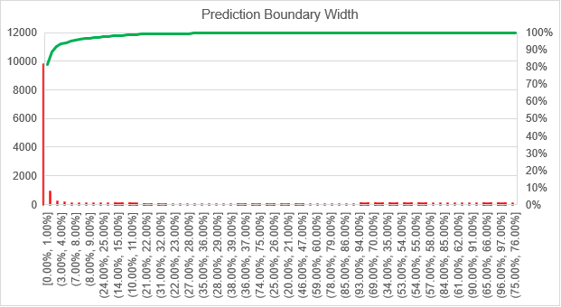

**Figure 5:** VennABER Prediction boundary width for 12000 data points

**Table 1:** Drives ranked as per descending order of failure probability distribution (n-days before)

Thus, based on average value of the boundaries and their difference, we can get the critical disks and their order of severity.

## 5.2 Variable Sparing Mechanism

After we rank the failing disks, we can know which RAID Groups (RG) are more prone to failure (based on the failing disks they contain). Then we can start optimizing the number of spares that would be enough for the RG.

We first start the process from the RG that has the highest-ranking failing disk. Below subsections explain how variable sparing works.

### 5.2.1 Architectural overview

Below is the architecture showing a change from the classical implementation discussed earlier.

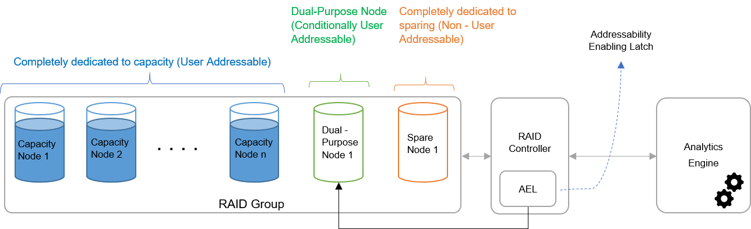

**Figure 6:** Proposed Implementation: Distribution of Capacity and Spare nodes

A minimum count of spares () as well as a maximum count () is maintained for every RG which will always be reserved for sparing. These counts are variable and depend upon the criticality of data the capacity nodes hold. Similarly, some nodes will always be reserved for holding user data. These are data/capacity nodes.

The difference, disks are made ‘Conditionally User-Addressable’ thereby serving as data node or spare node (Dual-Purpose (DP) disks), based on the criticality of other data disks of the RG.

The Analytics Engine comprising a classification Algorithm and Venn-ABERS method gives the probability of failure for the ‘failing’ disks identified by the classification algorithm. A probability threshold is defined above which a disk failure is considered serious. Here we take the threshold as 0.50. This means that if a disk has a probability of failure greater than 0.50, then we consider protecting its data by sparing. If the probability is less, then that disk would continue serving in near future, and does not need backing by a spare.

We also define an Addressability Enabling Latch (AEL) that enables and disables the user addressability of DP disks.

### 5.2.2 Workflow

Below is the workflow for variable sparing based on the output from analytics engine.

**Figure 7:** Workflow for Variable Sparing Mechanism

Two cases arise after the count of disks with failure probability greater than the threshold (*k*) is obtained. If this *k* is less than or equal to the *min spare*, it means the data disks are working fine and there is very less probability they may fail. This implies that *min spare* is enough for sparing purpose and the DP disks can be used to hold user data. Hence the AEL makes those disks available for writing to the *load balancer*. This results in enhanced performance of the overall RAID Group as the data nodes get less stressed. Failure probability builds slowly over time; hence, this process does not add any overhead of frequently copying the data across nodes.

However, for any changes in the probability output of failing disk, the DP disk should be capable of rolling back to ‘sparing’ role. For this, it is necessary not to fill the data nodes to the brim. A capacity rule needs to be maintained in order to initiate the transfer of all data from DP disk to data nodes. As an alternative, a new disk can be added to the RG. Considering the former case, the rule is given as:

Below figure shows the case discussed above:

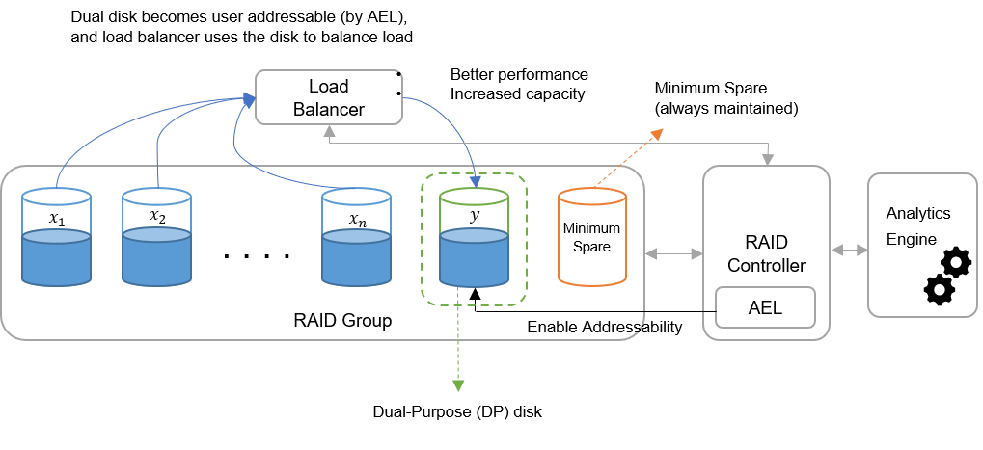

**Figure 8:** Case 1. Minimum Spare is sufficient (Probability of disk failure in RAID Group is less)

The second case arises when the RG has more disks expected to fail than the min spare. In this case, some DP disks need to be freed to be prepared for dealing with possible failure. For this, the data held by them should be copied to the other data disks. This phase called Copy Left Phase is instructed to the Load Balancer to carry out this operation by RAID Controller (after it gets the input from Analytics Engine). Once the data is copied, the AEL disables the user addressability of that DP disk and it becomes a spare disk. This phase is called Spare Augmentation. Below figures illustrate both these phases:

**Phase 1 – Copy Left**

**Phase 2 – Spare Augmentation**

**Figure 9:** Case 2: Minimum Spare is not sufficient

# 6. Novelty

**The main novelty** of our work are:

* The use of Venn-ABERS framework along with a classification algorithm makes prediction and gives the boundary range of probability; it also learns as it predicts, thereby continually improving the performance as it makes each new prediction and finds out how accurate it is.
* The Variable Sparing Mechanism dynamically changes the number of spares in a RAID Group based on the ‘failing’ disks present.
* The introduced dual-role of the disks reduces storage wastage by converting the spare disk to data disk if the spare is not needed and vice versa.

Classify and rank the fail-*ing* drives n-days before according to confidence of prediction

|  |  |  |  |
| --- | --- | --- | --- |
|  |  |  | |
| Classification | **Ordinary** | | **Probabilistic** | | **Venn-Aber** |
| Method | Single prediction | | Single probability distribution | | Set of Probabilities |
| Validity | Depends on data | | Guaranteed under statistical assumption | | Guaranteed in online setting |
| Efficiency | Algorithm dependent | | Algorithm dependent | | Dependent on Taxonomy used |

Proposed Sparing method – non-obviousness

|  |  |  |
| --- | --- | --- |
|  | **Prior Art** | **Inventive Step** |
| Technique | Fixed Sparing | Variable Sparing |
| Basis | Fixed/Rule Based | Disk Quality Based |
| Disk Role | Fixed (only Data or Only Spare) | Dual Role (Data or Spare) |
| Disk Utilization | Under-utilized | Optimum utilization |
| Read Performance | Regular | Better (When DP Disk acts as Data disk) |

1. SVM Classifier trains the model incrementally
   1. learns and predict simultaneously
   2. favours changing properties of predictor variables over time in unforeseen ways
   3. uses disk drive S.M.A.R.T parameters and SCSI return error value as a hybrid approach for feature selection
2. VennABER predictor complements the predictions of machine learning algorithms in (1) for reliable forecasts;
   1. provides boundary measures of probability which can be interpreted as an indication of the quality of prediction
   2. Probability-Boundary forecasting
3. The Variable Sparing mechanism helps in the optimum utilization of storage
   1. While most predictive algorithms give a binary output (Normal/Fail), it is hard to obtain the criticality of each failure with respect to the other.
   2. Dynamic allocation of spare to the failing RAID group removes the concern of a disk getting failed in future
   3. Variable sparing converts the Dual-Purpose disk to data or spare disk according to the health of RAID Group
   4. It is like an automatic role switching for the disk

# 7. Utility: Industrial Applicability

Across Data Centers that hold large number of disks to store user data and deploy multiple spares for data availability and fault tolerance.

Use cases for Dell include storage facilities deploying:

-        Dell Servers

-        Backup and Restore systems, e.g., Data Domain

-        Primary Storage array, e.g., PowerMax